Football
Format |  | Aim:
Number of Players | 7 per team | The game is played with two teams and the aim is score more goal than the other team in the allocated game time.
Game Time | 15 minutes per half. | Equipment | Football (Size 3 4 -7-year-olds, Size 4 8-11 year olds), Football Nets, Bibs.
Scoring |  | Main Rules
1 goal is given if the whole of the ball is over the goal line between the goal posts and under the crossbar.  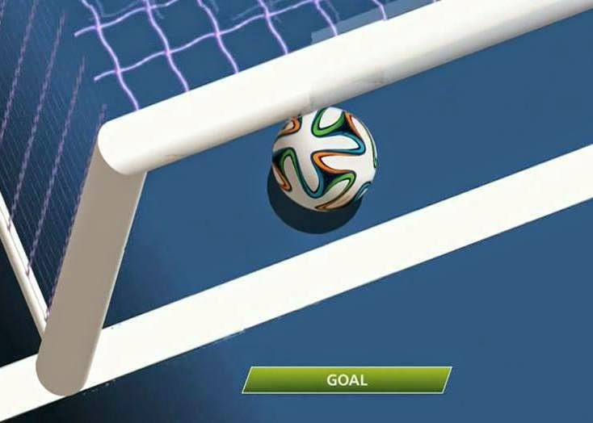  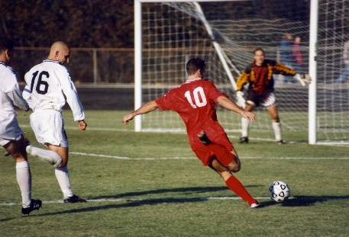 |  | - Each half is started by a kick off, one per team, a coin toss. If a goal is scored the conceding team will start with a kick off. Each team will stay in their own half until the kick off is taken.  - You need to keep yourself and the ball inside the playing area. If the ball leaves the pitch via the touch line, the opposing team restarts with a kick in (the ball must be stationary on the floor).  - If attacking team kicks the ball out of play of the oppositions goal line a goal kick is given to the opposing team. This must be taken anywhere in that team’s penalty area. If the defensive team hits the ball out of their own goal line, a corner kick is given to the opposing team.  - Each team consists of 1 goalkeeper, 6 outfield players. The goalkeeper can only use their hands in their team’s penalty area.  - If a player is fouled, then either of the below free kick can take place.
 |  | Types of Free Kicks
 |  | Indirect Free Kick |  | Direct Free Kick | Penalty Kick
 |  | This is a free kick that takes place from where the incident takes place. The ball must hit another player before it enters the goal. |  | This is a free kick that takes place from where the incident takes place. Ball can go straight in the goal from the kick. | This is taken from the penalty spot of the team who committed the foul.
 |  | It is awarded if a player:  - Touches or controls the ball with their hands after being kicked at them by a teammate.  - Plays in a dangerous manner.  - Stops the progress of an opponent when the ball is not being player.  - Prevents the goalkeeper from releasing the ball from his hands. |  | It is awarded if a player:  - Kicks, trips or strikes an opponent or an attempt is made.  - Jumps or charges at an opponent.  - Charges an opponent, even with the shoulder.  - Hold or pushes an opponent.  - Handles the ball deliberately, except the goalkeeper in the penalty area.  - Excessive force in a tackle. | It is awarded if a player:  - Any player commits any of the offences in their penalty box that would otherwise be a direct free kick elsewhere.
Diagram of Playing Area
